Energy Efficiency Investigation /35

There are many benefits to making a home energy efficient. This investigation will look at how to design an energy efficient house.

1. What does energy efficiency mean?

__________________________________________________________________________________________________________________________________________________________________________________________________________________________________________________________________________________________________________________________________________________________________________________________________________________________

(1 mark)

1. What are three benefits of having an energy efficient home?

__________________________________________________________________________________________________________________________________________________________________________________________________________________________________________________________________________________________________________________________________________________________________________________________________________________________

(3 marks)

1. For each of the places in the home explain how energy efficiency could be improved.

|  |  |  |  |
| --- | --- | --- | --- |
| Place in home | How efficiency can be improved | Marks |  |
| Roof colour |  | 3 |  |
| Roof cavity space |  | 3 |  |
| Windows | Double glazing. Explain what it is and how it works. | 3 |  |
| Reflective foil. Explain what it is and how it works. | 3 |  |
| Curtains. How do they work? | 4 |  |
| Garden | Shade trees. | 3 |  |
| Water heating | Solar | 2 |  |
| Changes in behaviour | 3 |  |
| Lighting | Which types of light are the most energy efficient? | 1 |  |

Write out your text book as a reference.

Write out one website as a reference.

(2 marks)

Onto this picture label all the things you have mentioned in your assignment.

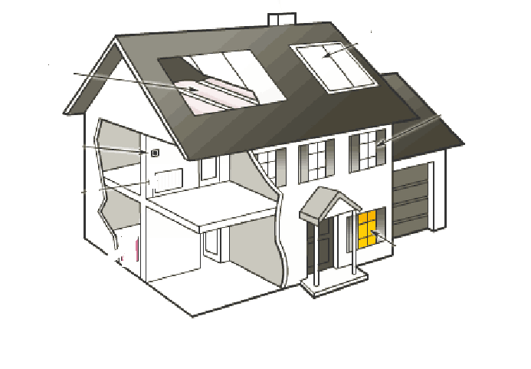

(4 marks)